OD OS

Header 3 Examination of Adnexa

20 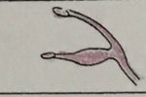 21

Eye Lids & Palpebral fissure

1-10

Eye Lids Conjunctivae

21 22

Eyelids bulbar conjunctiva

11-20

Nictitans Position (TEL)

23 24

Nictitans25 -26 27-28

Lacrimal Caruncle

Header 4. Cornea and sclera (Ocular Surface Study)

1-12

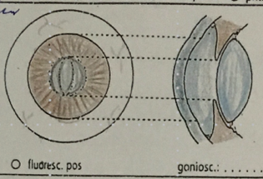 

Header 5 Anterior Chamber

1-15

Header 6 Anterior segment after Pupillary Dilatation

Lens and vitreous

1-10

Header 7 Posterior Segment After pupillary Dilation

Vitreous Body

1-8

Header 8 Fundus

3-19

